# Amazon Web Services - Review 2019 - PCMag AustraliaLAB: Setting Up VPC and Endpoint To Connect to Resources Without Going Over the Internet

# Setting up VPC . This VPC separates instances from resources. This acts as extra layer of security in case of data breach.This creates logically isolated network environment within public cloud..

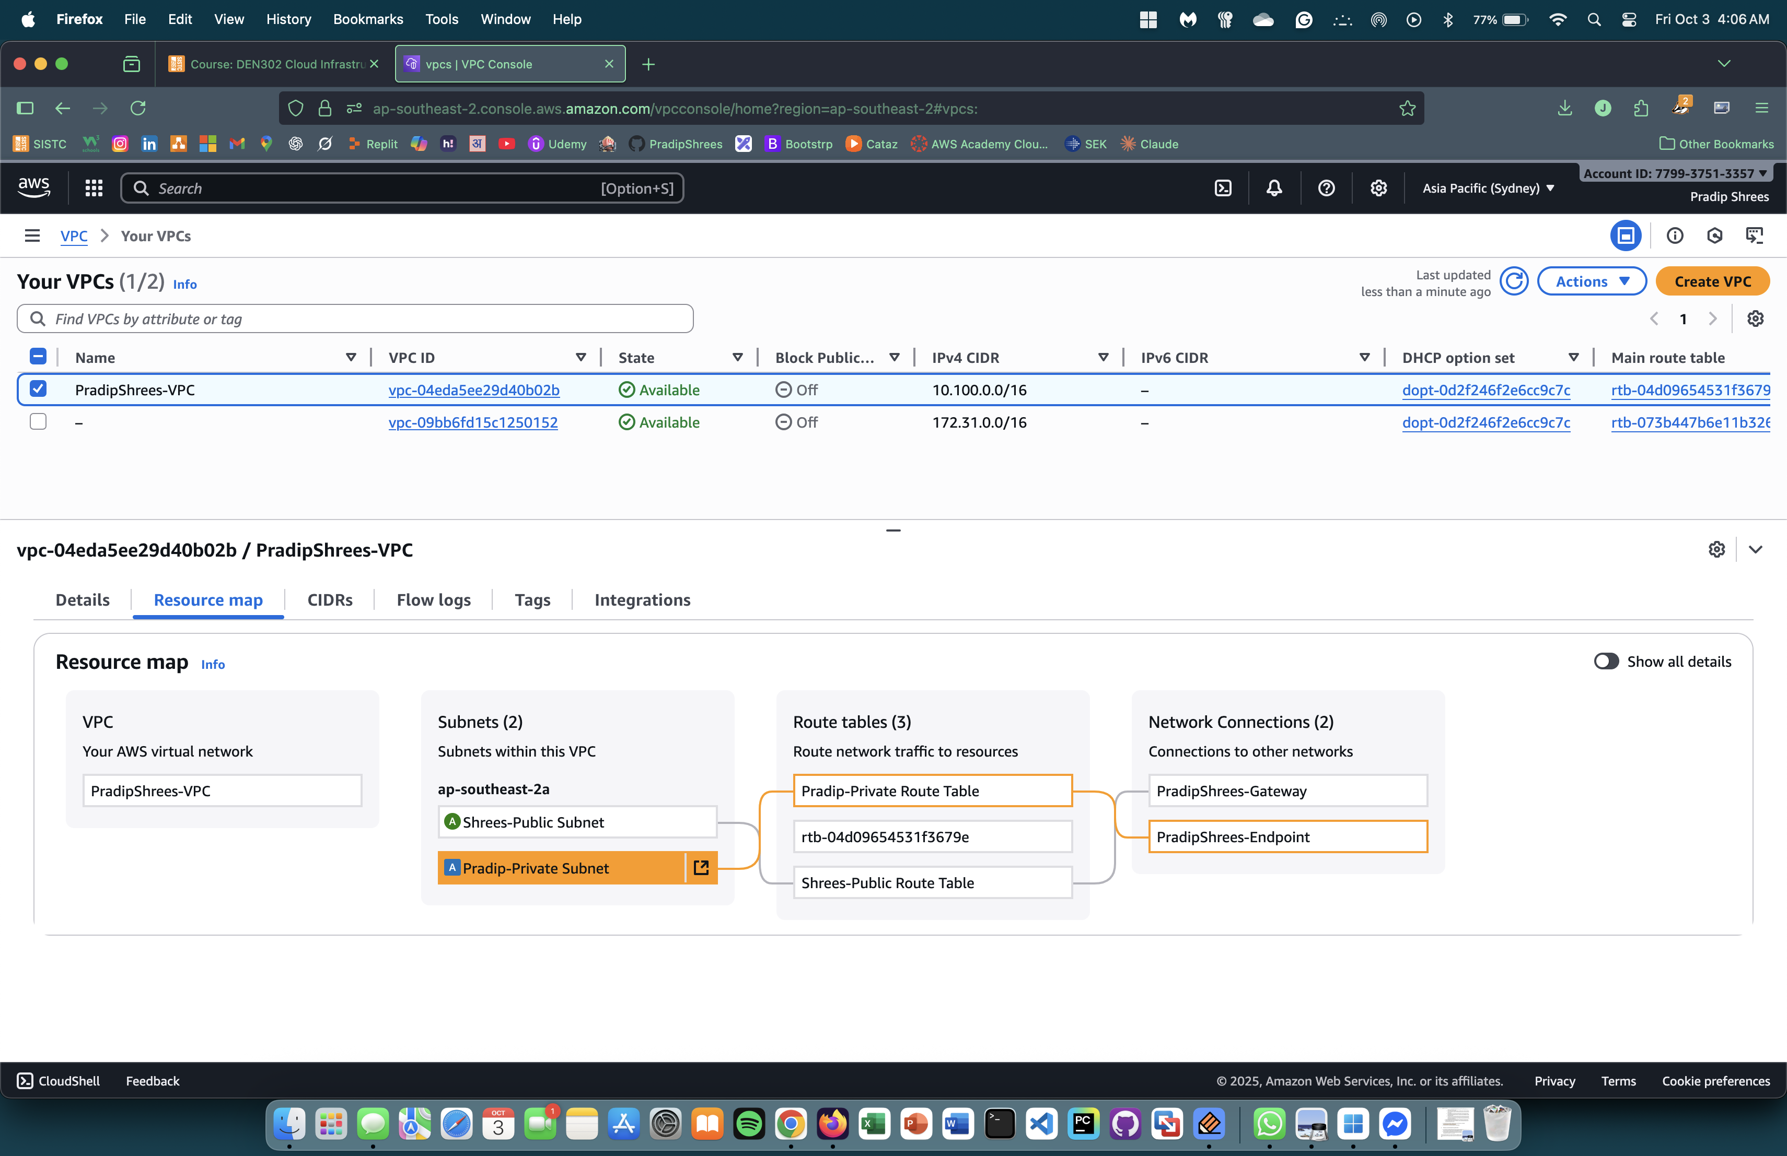

1. Setting up Subnet to Divide VPC into two part using CIDR. Subnet is a range of Ip addresses within a private cloud that serves as a segment for deploying cloud resources and allowing resource isolation.

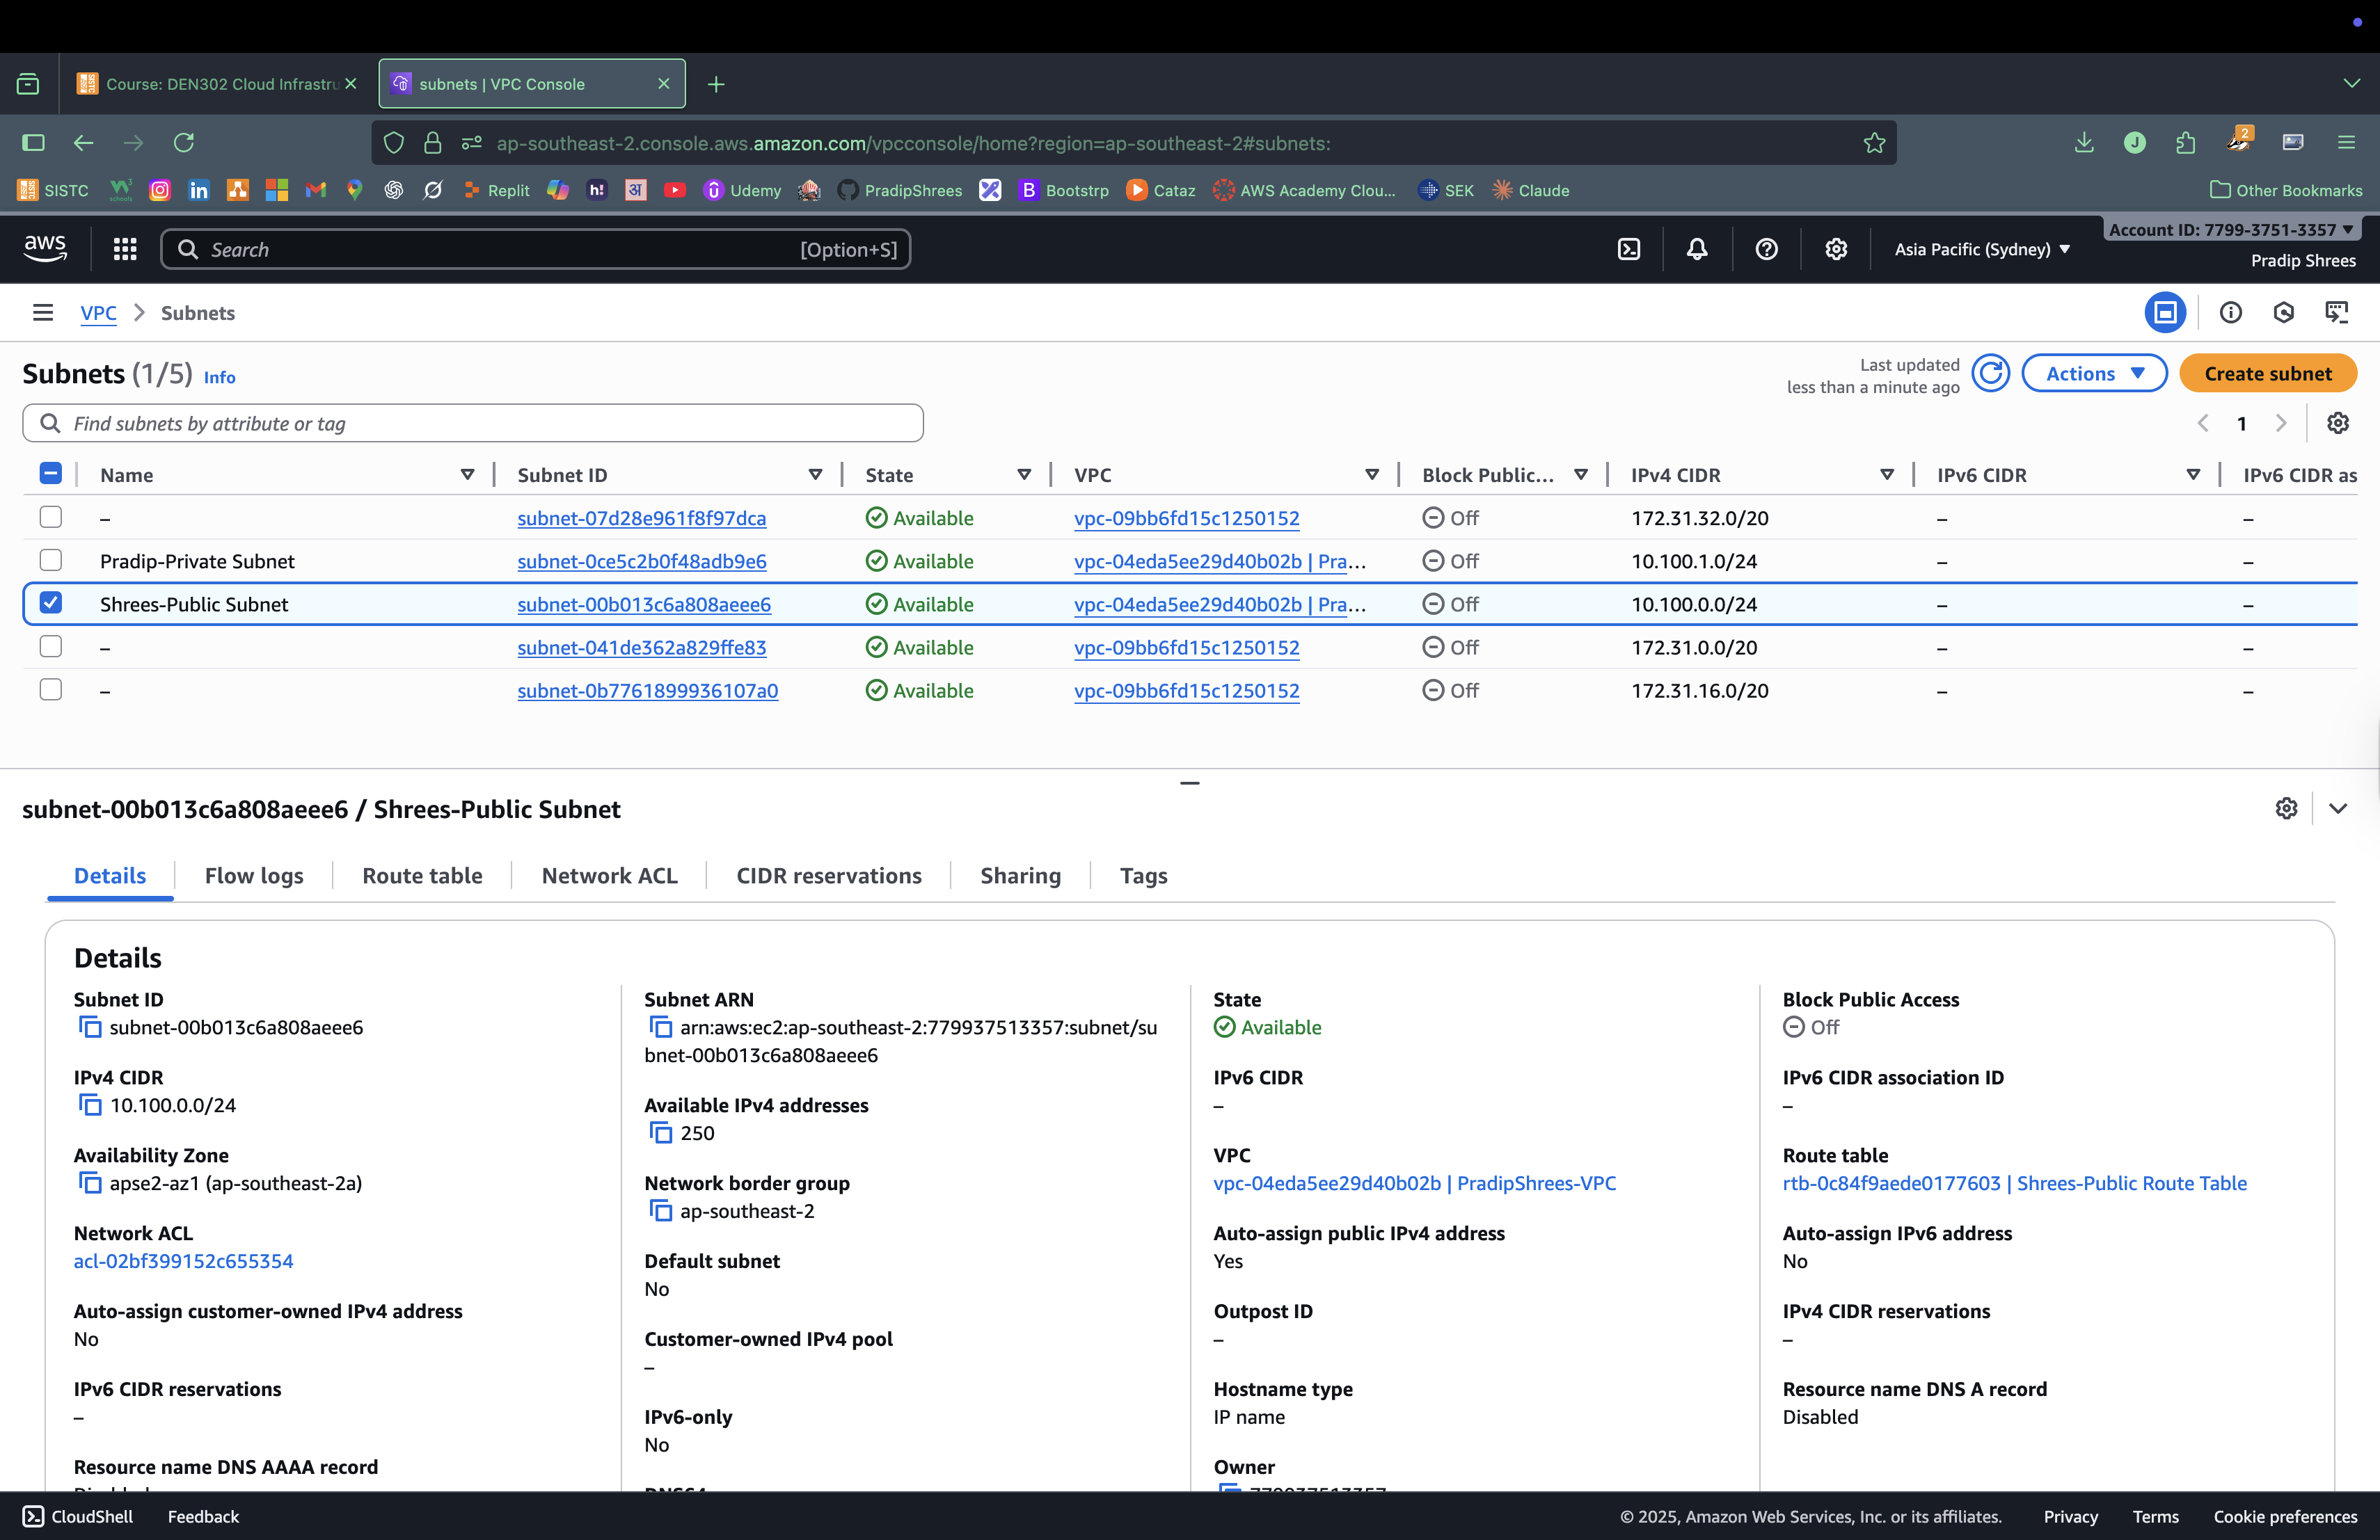

1. Setting up the Route Table to set the connection from the instance to the internet. We have two different route tables so that we can configure how traffic flows within VPC subnet.

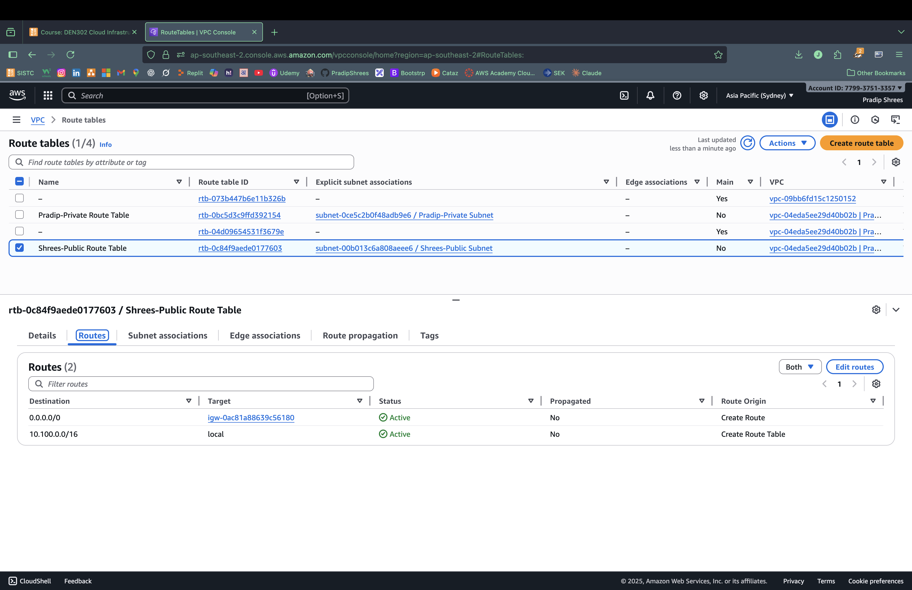

1. Setting up VPC Endpoint to connect private instance to S3. VPC Endpoint creates a private, secure connection to supported AWS services and other VPC endpoints eliminating the need to go through internet.

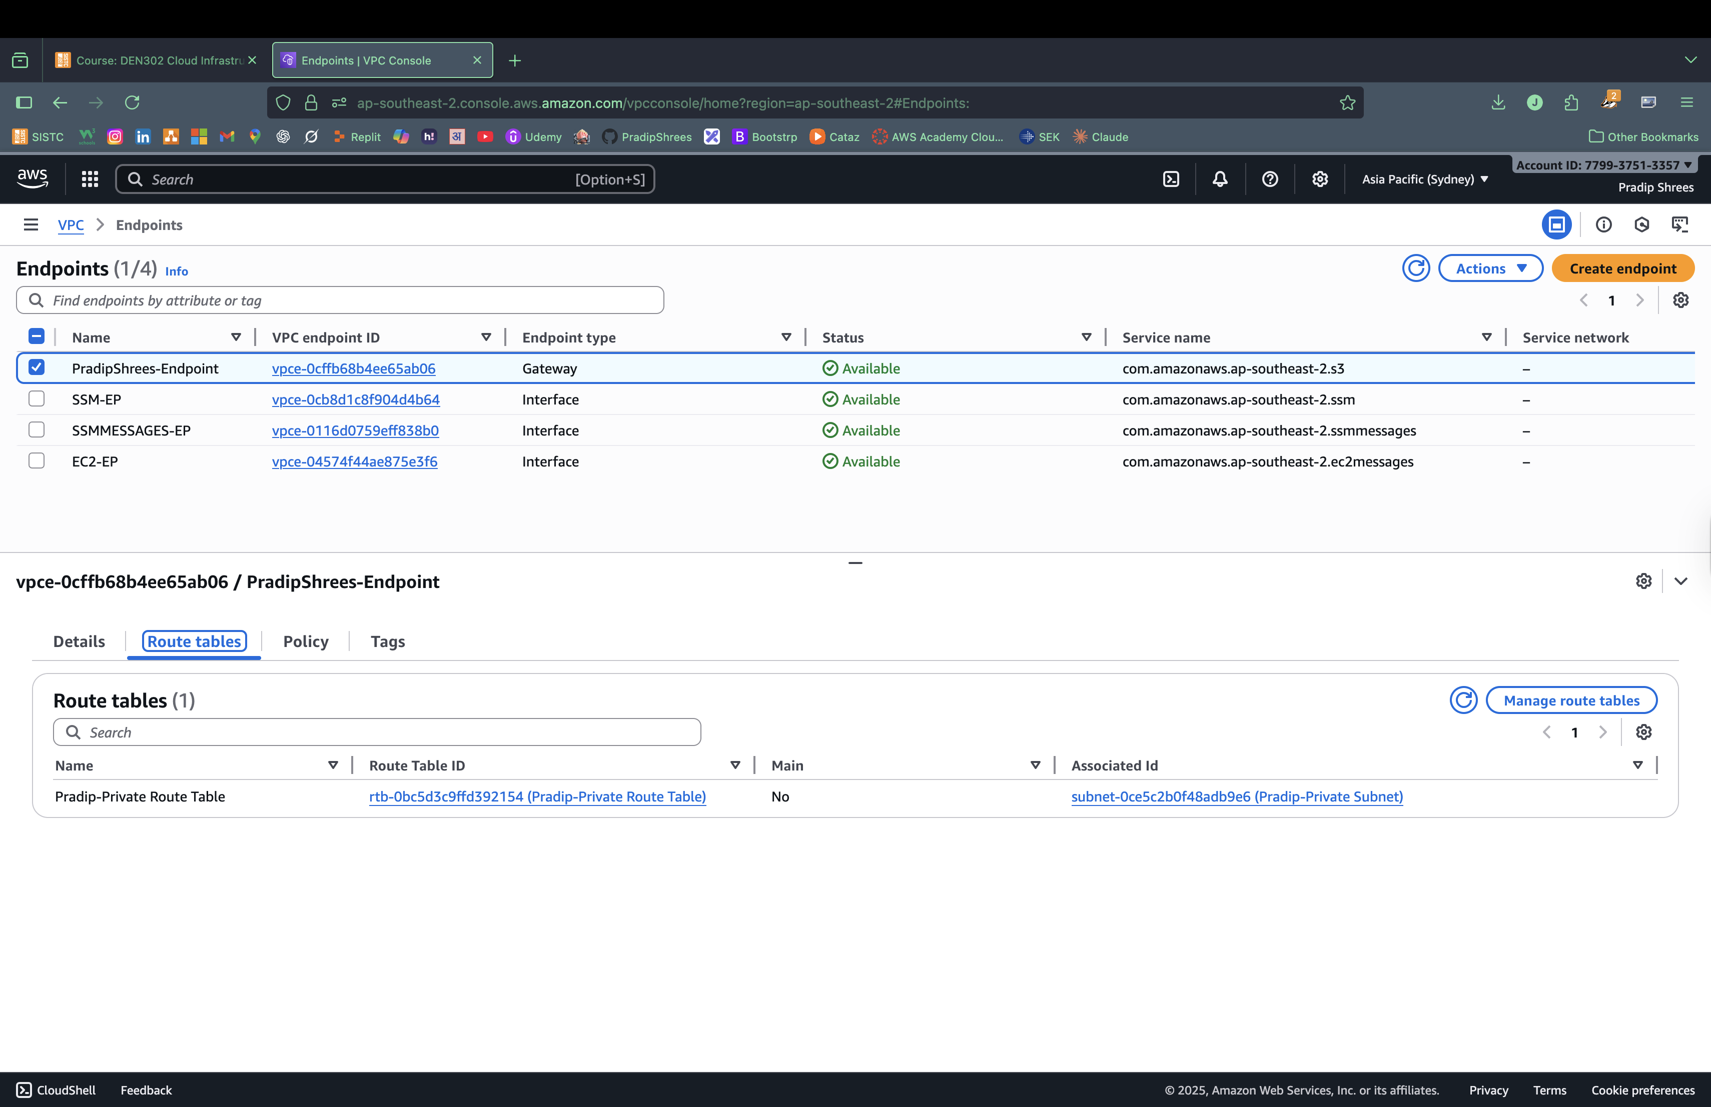

1. Setting up S3. S3 is a simple storage service that allows users to store and retrieve any amount of data from the web. The limit on one single object is 5TB. This provides flexibility and durability with security.

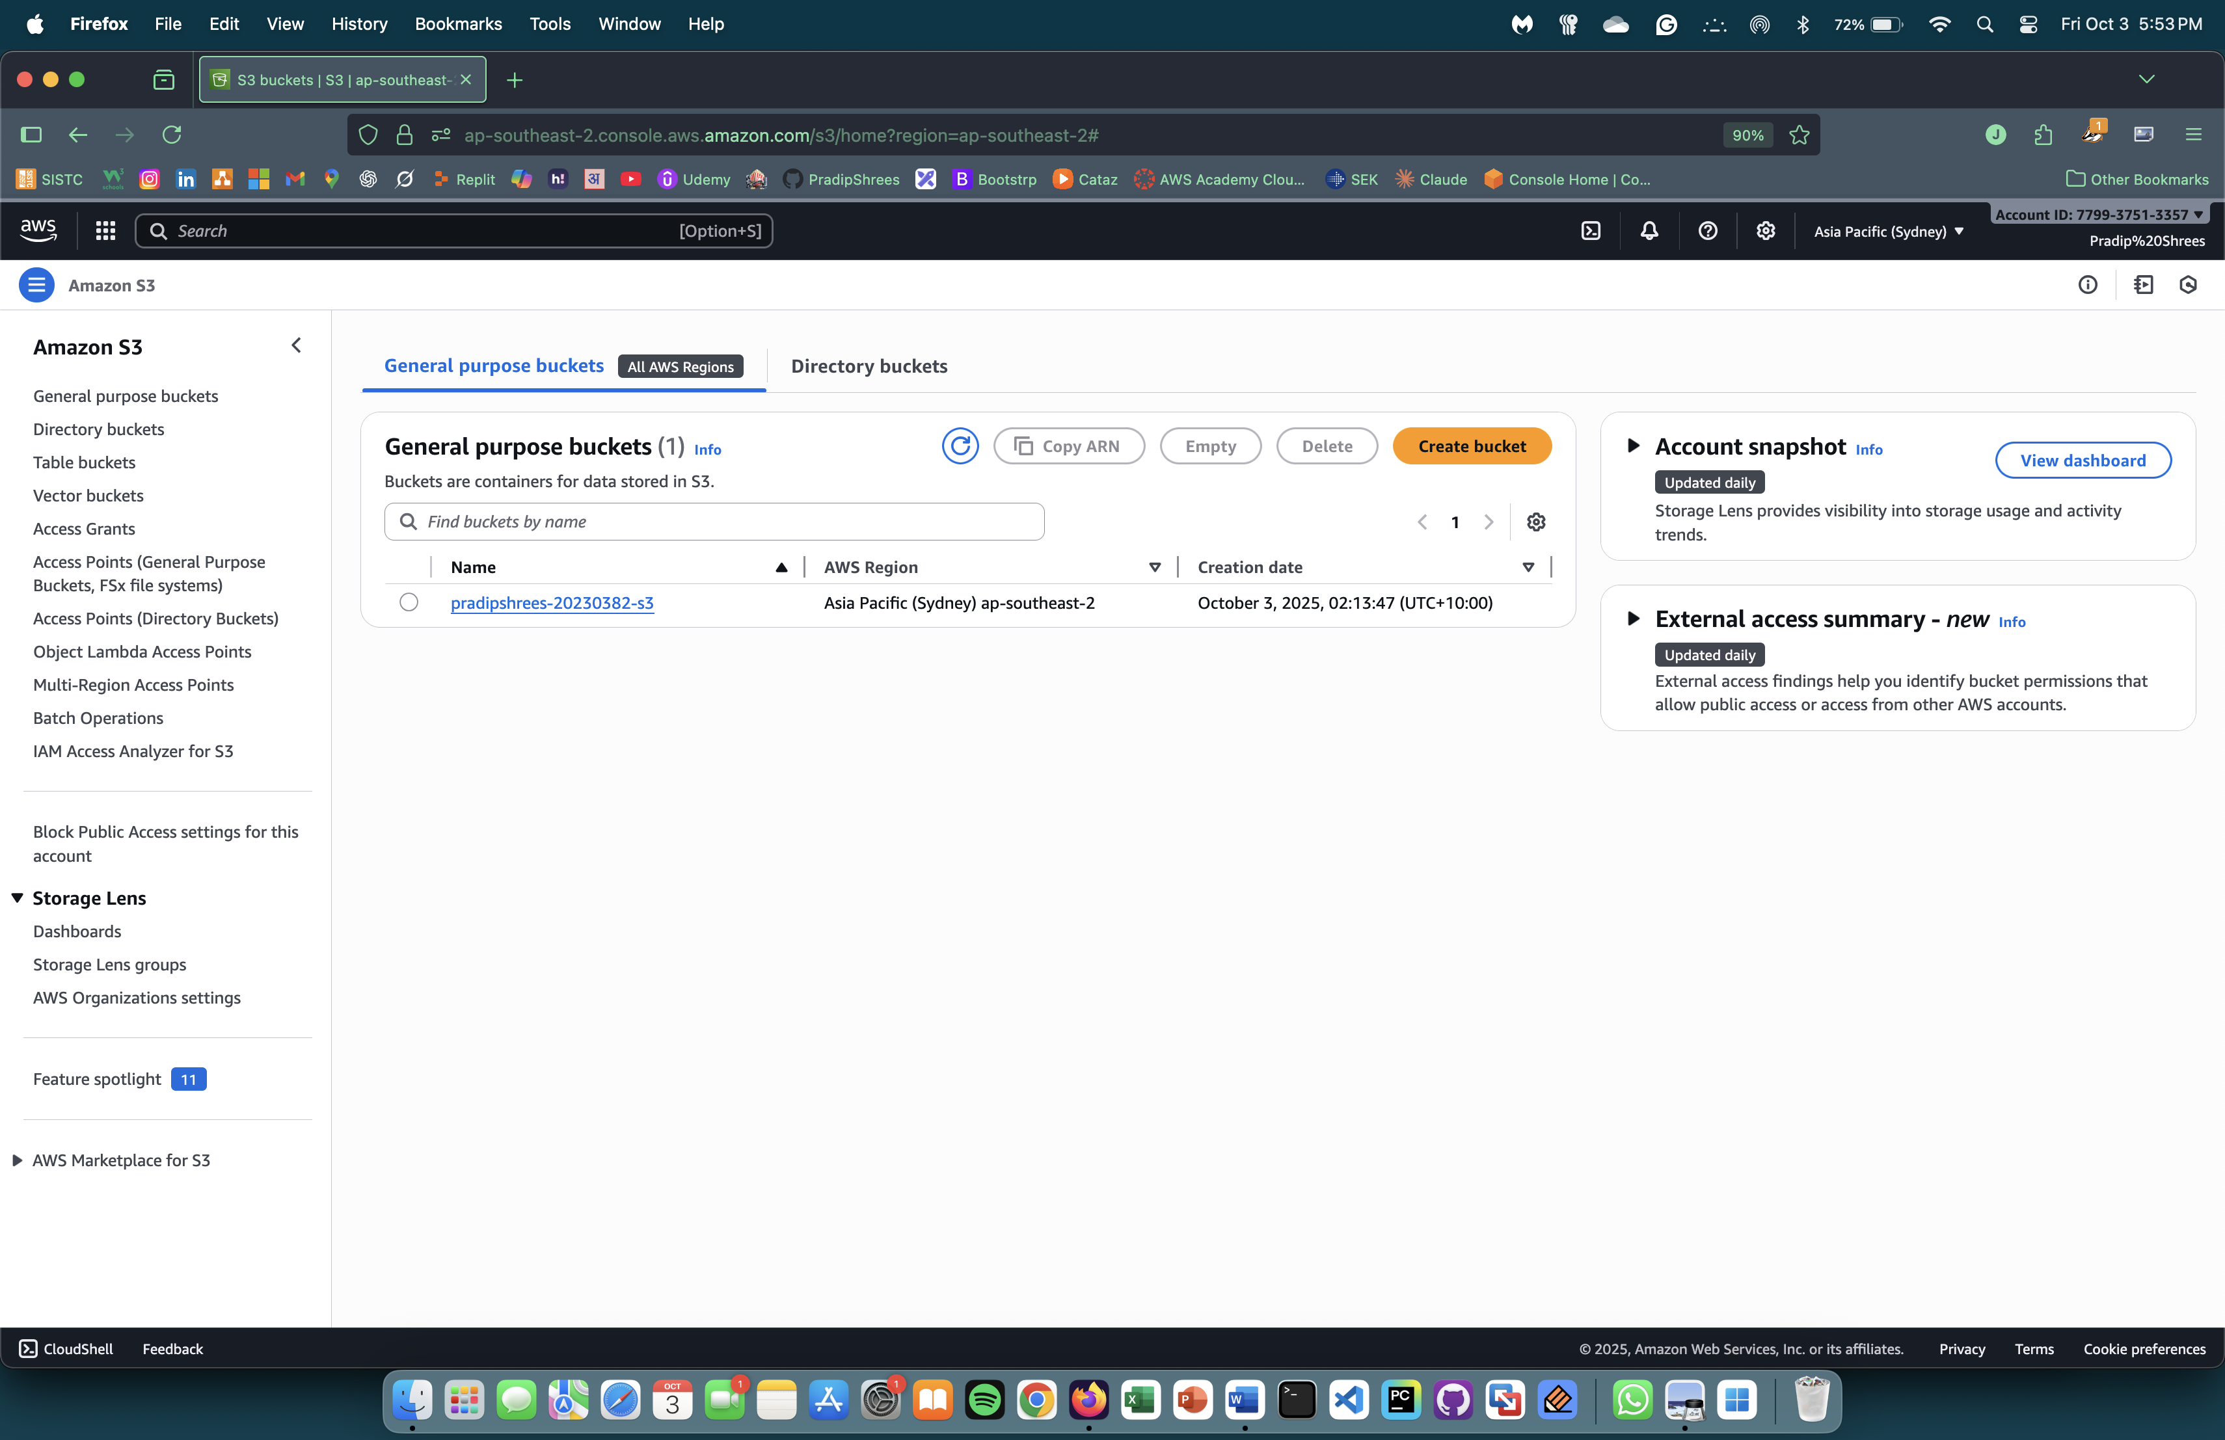

1. Creating two instance . One is public instance and another is private instance which we connect with S3 with VPC Endpoint.

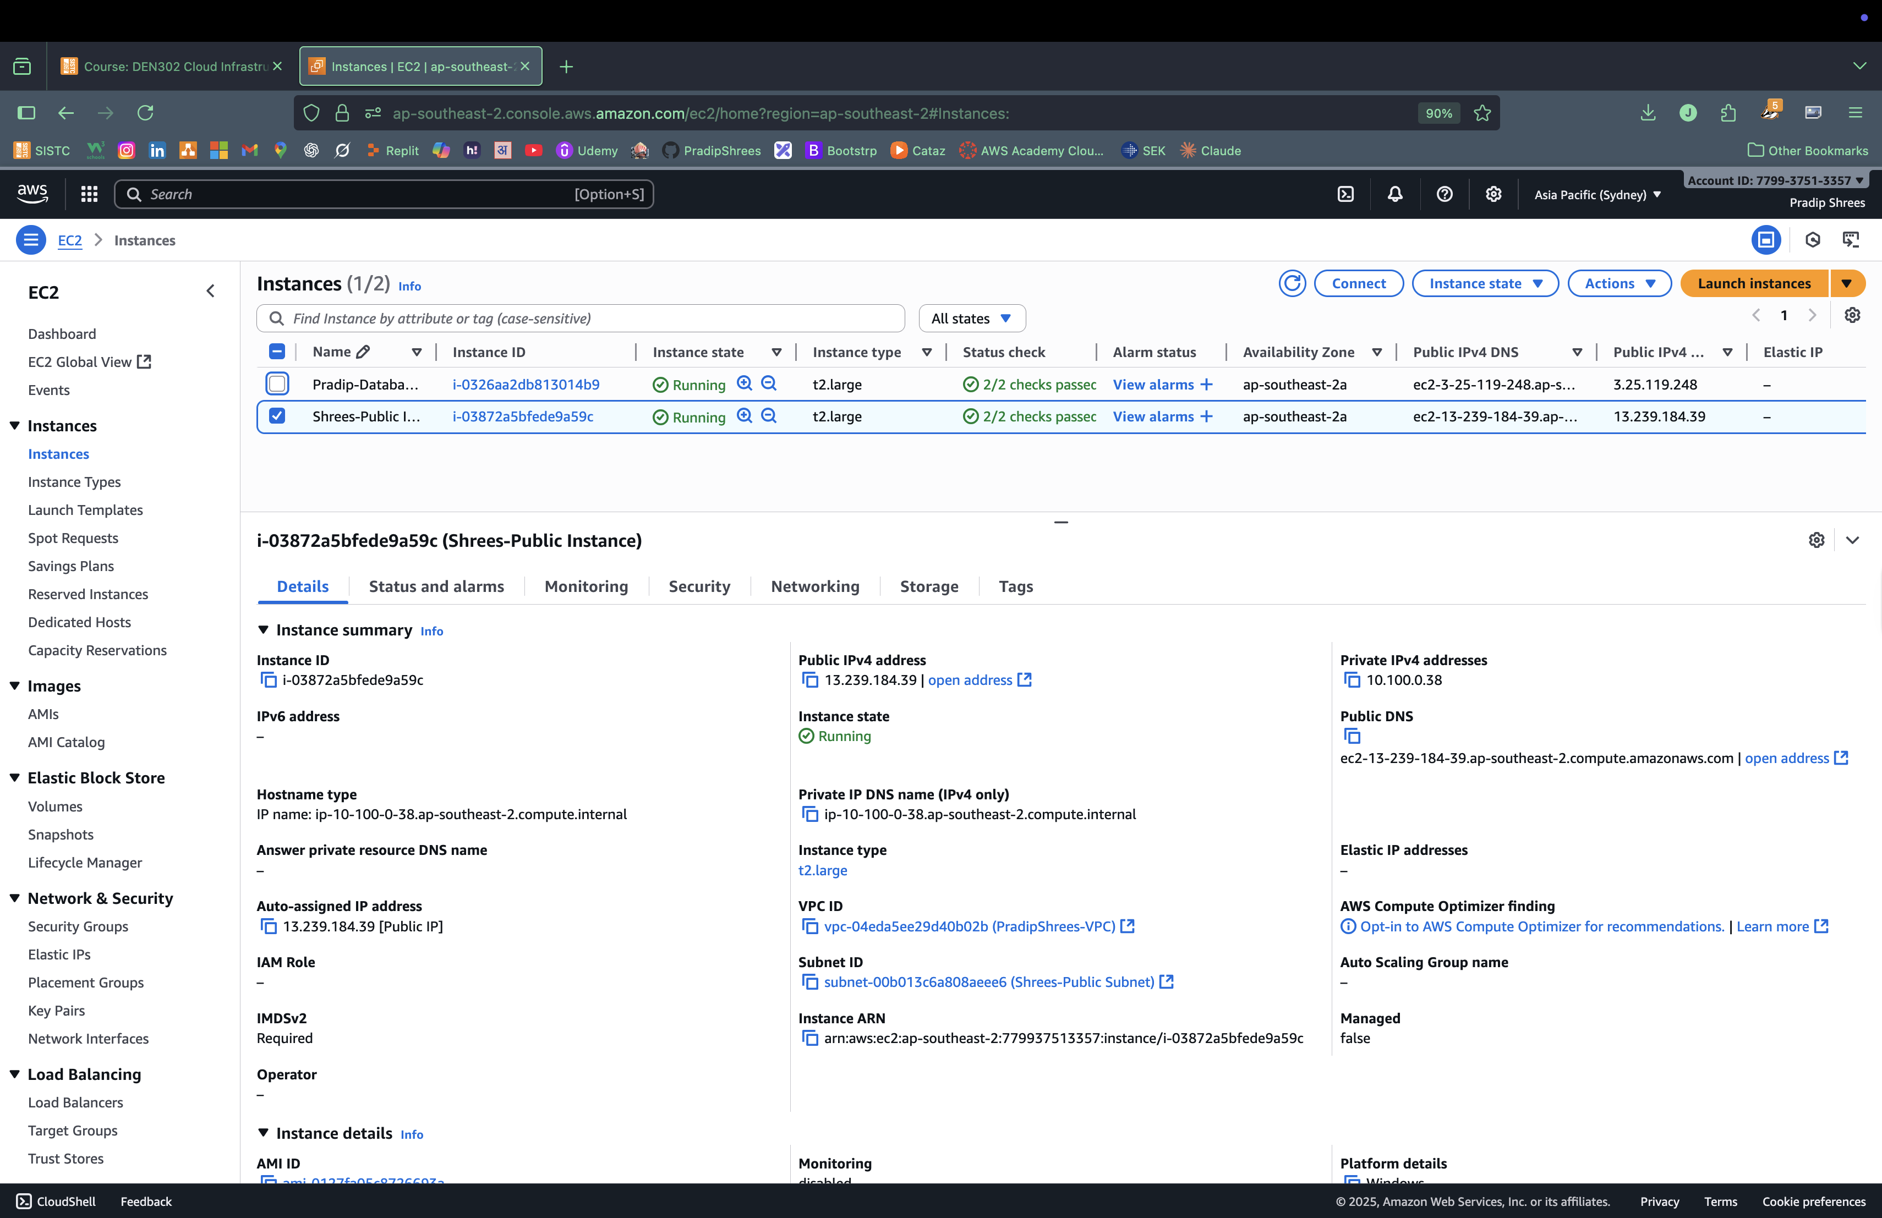

1. Picture showing that we can upload file using AWS Cli . One half screen shows CLI and Another half shows bucket having that file which means it is successfully uploaded from Private instance using cli.

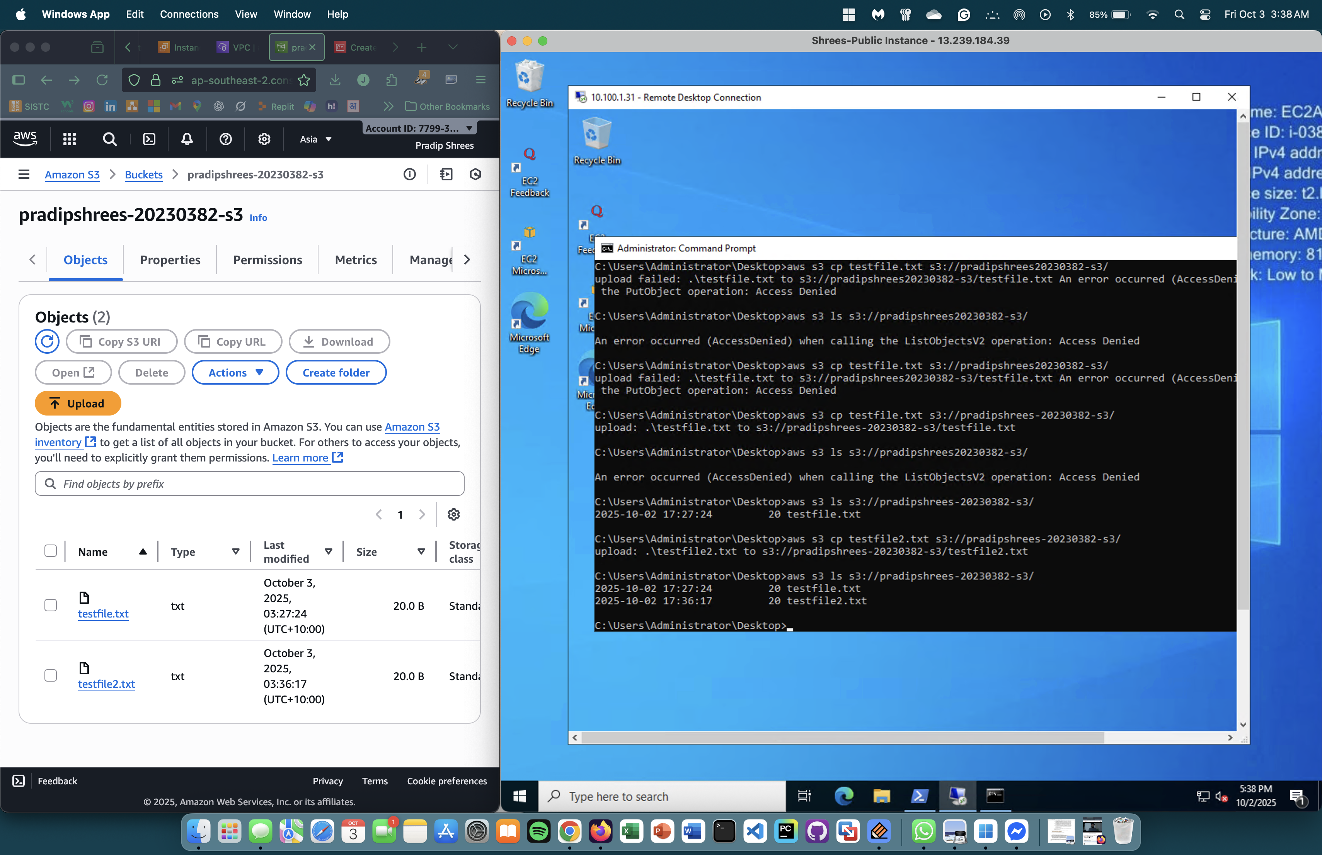

1. To block other pc or instances connecting to our S3 , we need to update the bucket policy which only allows connection only from VPC Endpoint Route.

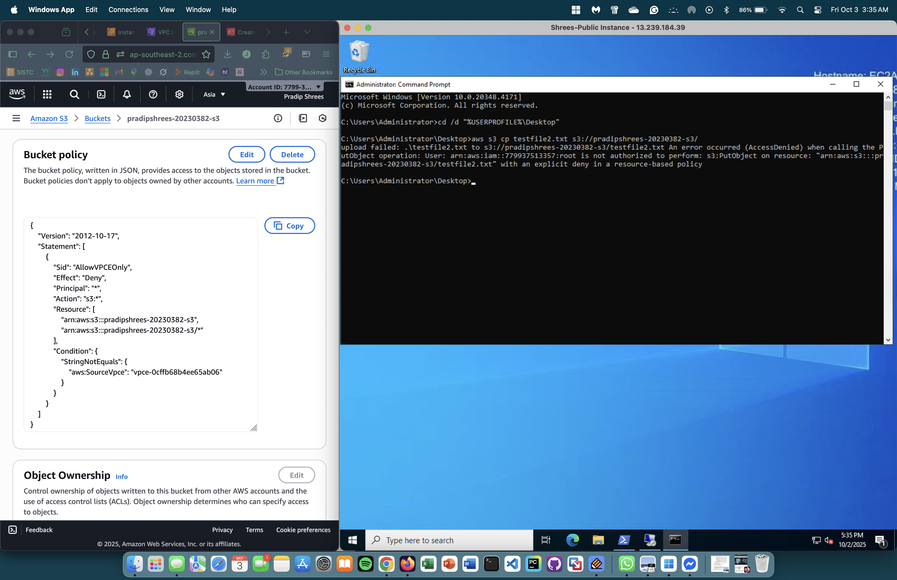

1. This shows that we can connect to S3 from our private instance even without going over the internet. This is possible because of VPC endpoint which bypasses internet need to connect. Intially I had to connect NAT to private instance to install python and AWS Cli and configure it. After that I deleted the NAT and uploaded file from private instance and listed file that are present in S3. I also pinged 1.1.1.1 to show that the instance is not connected to the internet.

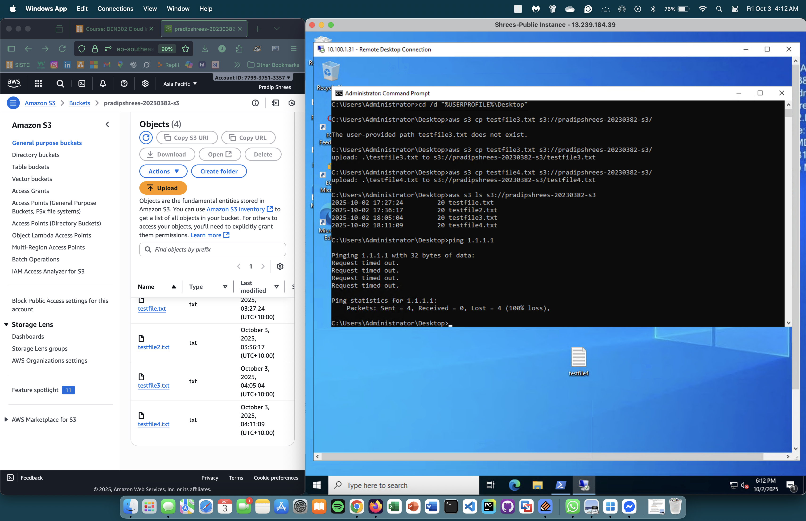

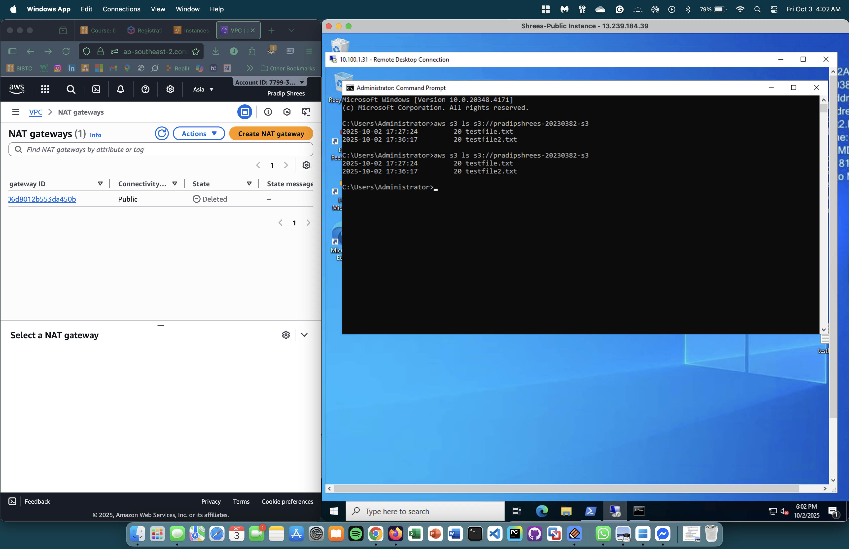

“Thankyou”